CO-1 ASSESSMENT TOOL -OUTPUT PREDICTION
COUSE CODE: CSA0307 NAME:S. AHMAD ALISHA
COUSE NAME : DATA STRUCTURES REG NO: 192525415
DATE : 24/07/26
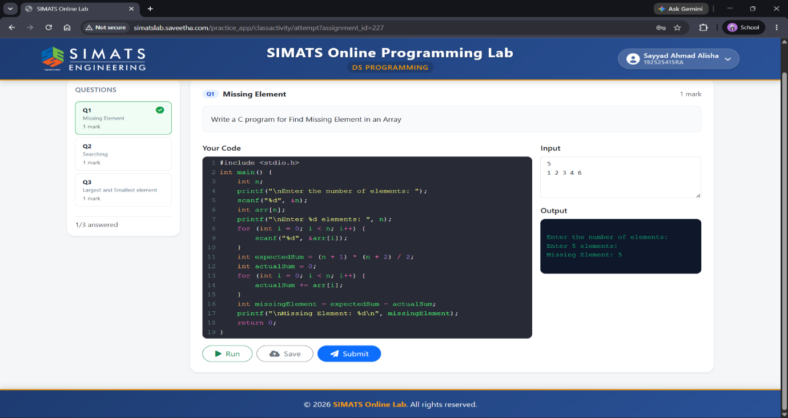
QUESTION 1 MISSING ELEMENT
QUESTION 2 SEARCHING AN ELEMENT
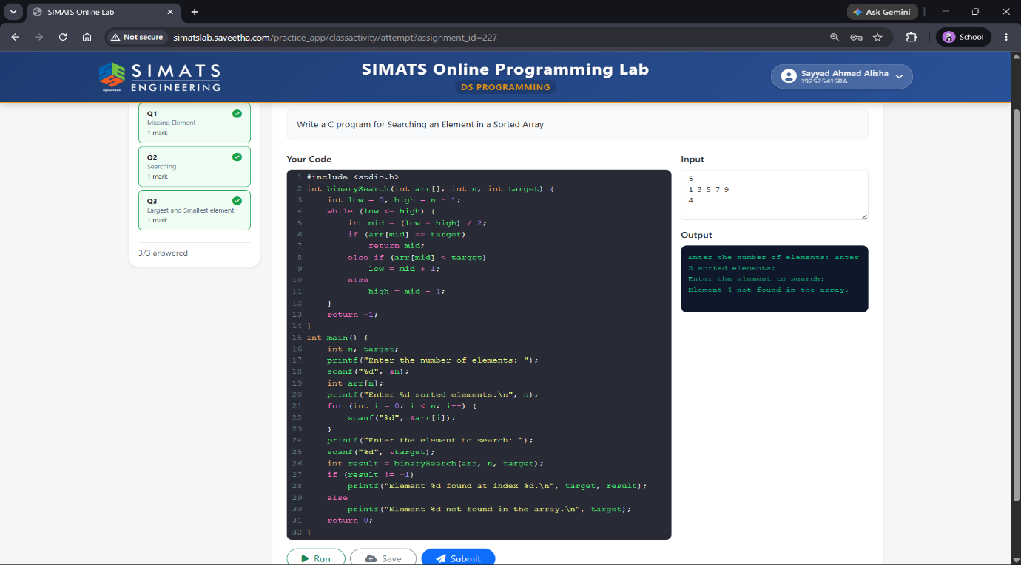
QUESTION 3 LARGEST AND SMALLEST ELEMENT
